Business economics as a field in applied economics uses economic theory and quantitative methods to analyze business enterprises and the factors contributing to the diversity of organizational structures and the relationships of firms with labour, Capital and product markets.[1] A professional focus of the journal Business Economics has been expressed as providing "practical information for people who apply economics in their jobs.
Part I: Micro-economics
Week 1. Introduction to Economics & Key Concepts
Week 2. Demand, Supply and Operations of Markets
Week 3. Competitive Markets and Market Efficiency
Week 4. Production Costs and Perfect Competition
Week 5. Imperfect Competition
Week 6. Market Failures and the Role of Government Policies
Week 7. Mid-term exam
Part II: Macroeconomics
Week 8. Measurement –National Output and Price Indices.
Week 9. The Economy in the Long Run: The Financial System
Week 10. Unemployment, Inflation and Money
Week 11. The Open Economy
Week 12. The Economy in the Short Run
Week 13. Summary & Revision
Business economics is concerned with economic issues and problems related to business organization, management, and strategy. Issues and problems include: an explanation of why firms emerge and exist; why they expand: horizontally, vertically and spacially; the role of entrepreneurs and entrepreneurship; the significance of organizational structure; the relationship of firms with the employees, the providers of capital, the customers, the government; the interactions between firms and the business environment.
Ambiguity in the use of term: The term 'business economics' is used in a variety of ways. Sometimes it is used as synonymously with industrial economics/industrial organisation, managerial economics, and economics for business. Still, there may be substantial differences in the usage of 'economics for business' and 'managerial economics' with the latter used more narrowly. One view of the distinctions between these would be that business economics is wider in its scope than industrial economics in that it would be concerned not only with "industry" but also businesses in the service sector. Economics for business looks at the major principles of economics but focuses on applying these economic principles to the real world of business. Managerial economics is the application of economic methods in the managerial decision-making process.
Economics: The branch of knowledge concerned with the production, consumption, and transfer of wealth. The condition of a region or group as regards material prosperity.
Economics is the social science that analyzes the production, distribution, and consumption of goods and services.
Microeconomics examines the behavior of basic elements in the economy, including individual agents (such as households and firms or as buyers and sellers) and markets, and their interactions. Macroeconomics analyzes the entire economy and issues affecting it, including unemployment, inflation, economic growth, and monetary and fiscal policy.
Other broad distinctions include those between positive economics (describing "what is") and normative economics (advocating "what ought to be"); between economic theory and applied economics; between rational and behavioral economics; and between mainstream economics (more "orthodox" dealing with the "rationality-individualism-equilibrium nexus") and heterodox economics (more "radical" dealing with the "institutions-history-social structure nexus").[3]
Economic analysis may be applied throughout society, as in business, finance, health care, and government, but also to such diverse subjects as crime,[4] education,[5] the family, law, politics, religion,[6] social institutions, war,[7] and science.[8] At the turn of the 21st century, the expanding domain of economics in the social sciences has been described as economic imperialism.
Importance of economics: The importance of economic studies has increased following the evolution and development of production strategies, and the expansion of economic activity. The conflict between East and West is purely economic. The present world problems are caused by the emergence of Europe. Japan and China as world economic powers. The major problem of the Third World, represented by Asia, Africa and Latin America, is underdevelopment. The world’s main concern today remains economic development. (Cf. Namiq 1968; Nasr (1965)
Economics deals with the laws and principles which govern the functioning of an economy and its various parts. An economy exists because of two basic facts. Firstly, human wants for goods and services are unlimited and secondly, productive resources with which to produce goods and services are scarce. Therefore, an economy has to decide how to use its scarce resources to obtain the maximum possible satisfaction of the members of the society. It is this basic problem of scarcity which gives rise to many of the economic problems.
Note: Dr Nasr(1965 309) argues that national progress means good longevity average for the people (about 70 years in the West). a high standard of living, provision of various health. educational and leisure services. National progress means the use of machines to replace man in doing oppressive work. It means respecting Man giving women their rights and not allowing children to work at an early age. Last, but not least, it means development and enrichment at fast speed. Underdevelopment in a given country means short longevity (between 30 and 40 years in poor countries). lack or insufficiency of proper food. Clothing and housing. It means the spread of disease. Ignorance and witchcraft as well as that of unemployment and the exploiting of workers. It is employing women and children in exhausting jobs. It is also dictatorship of parliament, when there is one. and the slow rate of development if it ever takes place. In many cases, underdevelopment also means backwardness due to the increase of the population and the decrease of production”.
Twin theory is twin deficits theory: Trade deficit and budget deficit.
Logic of economics: Economic logic is used in colloquial language as the applictions of certain forms of economic thinking in policy making and management (whether capitalism or socialism).
Country size and the unemployment rate: When firms merge, they mention economies of scale and sharing of fix costs. They also sometimes imply increased market power. When firms shed business lines to shrink, they put forward concentrating on core business. From this, it is not very clear where it is an advantage to have a large or small firm. What about countries? Are large countries more successful? One way to look at it, is to compare the unemployment rate to country size. Why not.
Norbert Berthold and Klaus Gründler did that and find that small is beautiful. Indeed they find a positive correlation of the unemployment rate with population and with area, looking at subcontinents, countries and regions within countries. How could that be? They first offer a bizarre explanation, using a Cobb-Douglas production function where they substitute labor by population times the employment rate, then isolating the unemployment rate. Of course, if you leave the other factors constant, increasing population will increase the unemployment rate. The problem is that the other factors are not constant. The paper later ties the correlations in a parabolic way to collective bargaining and the size of the government, the reasoning being rather obscure.
What bugs me more about the paper, though, is first the underlying assumption that each data point (a region) is treated like a closed economy. Regions trade with each other, and this implies that labor markets are linked. This is especially the case when you look at Europe today where borders have much less significance than just ten years ago. Second, the analysis is performed for 2010, not long term averages. All what is said is thus valid for a particular point in the business cycle. Finally, nowhere in the text it is mentioned that populous regions may have different characteristics that could matter for unemployment, say they are more urban, have more manufacturing, are more diversified. After all, these regions are accidents of geography and history, and both lend some economic characteristics to them. And these are the ones that matter. Otherwise, you would get the idea that you just need to administratively split up countries, and immediately a labor market miracle happens.
- Fiscal and monetary policies
- Divorce risk is good for the savings rate
- The housing bubble: fooled by efficiency
- Risk preferences, oil crisis!
- The Econophysics of migration
- Banking operation
- Understanding Chinese household savings
- The econophysics of religion
- I do not understand US policy
- Shopping hours competition
- Fiscal policy and climate change
- Tax rates over the business cycle

Three problems of economics:
- what to produce 2) how to produce 3) for whom to produce.
WHAT , HOW & FOR WHOM TO PRODUCE: by observing the current market strategy one should assess according to the consumption and consumers demand behhaviour that is any thing in your local market which is fully unavailable or shortly available as per its demand or available but on expensive price which may be because of import and if we may produce it locally by maintaining the standard of available imported product on the cheeper rate, which will emphasize the consumer to shift its demand on the alternative product of same standard on cheeper rate.
The basic economic problem is the unlimited wants and needs of human which results to scarcity of resources. what are the needs? the needs (for sustain) are the things we must posses in order to survive like food,water, clothing,shelter. while the wants are those things that human would like to have in order to improve there status in life. we limited resources that'a why encounter this problem. the economic resources like land, labor,and capital which are the factors if production are insufficient to satisfy our needs and wants.

Market vs. Command Economy
An economy may be defined as the state of a country or region in terms of the production and consumption of goods and services, and the supply of money.

A market economy (also called a free market economy, free enterprise economy) is an economic system in which the production and distribution of goods and services takes place through the mechanism of free markets guided by a free price system .

On the other hand, a command economy (also known as planned economy) is an economic system in which the state or government controls the factors of production and makes all decisions about their use and about the distribution of income . There is another type of economy, known as Mixed economy. Mixed Economy is combination of free market and command economy. However, this essay will analyze the main key difference between command and free market.

A command system is one in which decision making is centralized. In a command economy, the government controls the factors of production and makes all decisions about their use and about the consumption of output. The central planning unit takes the inputs of the economy and directs them into outputs in a socially desirable manner. This requires a careful balancing between output goals and available resources. Resources is allocated through a planning process. At its most extreme, this means that the state will direct labor into jobs as well as directing consumers what to consume, although it is more likely that they will direct producers what to produce, thus determining the choice of goods available to consumers. What is more, price is controlled by government, they decide minimum and maximum price of goods according to their importance. For instance, one the one hand, government sets the minimum price for wheat to encourage farmers to produce more. On the other hand, government sets the maximum price on rents so every one can easily afford that. In a command economy, the state plans the allocation of resources between current consumption and investment for future, the output of each industry and firm, methods of production and the resources allocated to each industry and firm. Moreover, in a command economy, all factors of production apart from labor are owned by the state. The classic examples of command economies were the USSR under Stalin and the People's Republic of China during Mao's Great Leap Forward.

In contrast, in a free market economy, all economic decisions are taken by individuals and firms, which are assumed to act in their own self-interest. Firms decide what goods shall we produce? They can produce what ever they want to acquire their maximum profit. They can produce necessity goods such as foods, clothes, tables and chairs. Moreover, they decide the prices of goods as guided by the laws of demand and supply. For instance, one firm produces Flat TVs, if Flat TVs are highly demanded, Prices increase dramatically. However, demand of black and white TVs decrease, consequently prices decrease. In addition, in a free market economy, the output is determined by the quantity demand, the techniques of production by the firms themselves keeping in mind efficiency and productivity and land is free to buy for everyone (firms, business invertors and etc). The free market idea of land ownership can have some good and some disastrous effects. On the one hand, land ownership is good because this gives the opportunity to business person to plan for long term with out having any problems such as, rent or charges on the land will increase after few years. On the other hand, land prices will increase dramatically which will affect the whole country. For instance, residential land values in Japan grew seven times faster than wages between 1950 and 1988 . This wrecked Japan's economy and it has taken 16 years to recover. The common examples of free market are USA, China and Canada.

To sum up, world has scarce resources. The economic systems of countries are designed to allocate those resources, through a production system, to provide output for their citizens. The fundamental questions that these systems answer are: what to produce, how and for whom? Market economies leave the answers to these questions to the determination of the forces of supply and demand while command economies use a central planning agency to direct the activities of the economy. Both have their own strengths and weaknesses. But in really world, all economies are actually mixed economies, incorporating some facts of both market and command economies. The relative importance of the particular economic system in the country is the determinant of the type of economic system that it is generally considered to be.

Input and output: Inputs are factors of production (land, labor, capital and entrepreneurship) and output is the final good or service produced using the factors of production through a production process.

PPF: A PPF shows the different combinations of goods and services that can be produced with a given amount of resources in their most efficient way. Any point inside the curve – suggests resources are not being utilized efficiently. Any point outside the curve is not attainable with the current level of resources (like consumer equilibrium). More see Salvatore.
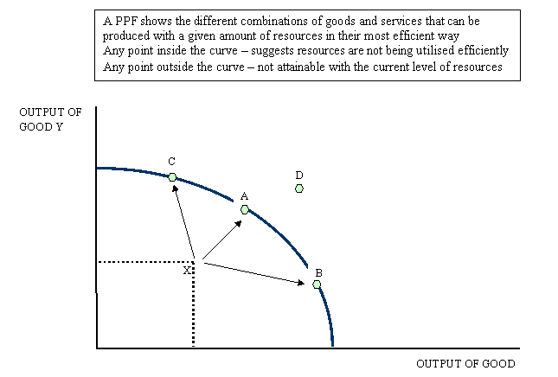
Combinations of output of goods X and Y lying inside the PPF occur when there are unemployed resources or when the economy uses resources inefficiently. In the diagram above, point X is an example of this. We could increase total output by moving towards the production possibility frontier and reaching any of points C, A or B.

Point D is unattainable at the moment because it lies beyond the PPF. A country would require an increase in factor resources, or an increase in the efficiency (or productivity) of factor resources or an improvement in technology to reach this combination of Good X and Good Y. If we achieve this then output combination D may become attainable.

Producing more of both goods would represent an improvement in our economic welfare providing that the products are giving consumers a positive satisfaction and therefore an improvement in what is called allocative efficiency. Reallocating scarce resources from one product to another involves an opportunity cost. If we go back to the previous PPF diagram, if we increase our output of Good X (i.e. a movement along the PPF from point A to point B) then fewer resources are available to produce good Y. Because of the shape of the PPF the opportunity cost of switching resources increases – i.e. we have to give up more of Good Y to achieve gains in the output of good X.

The cobweb model is based on a time lag between supply and demand decisions. Agricultural markets are a context where the cobweb model might apply, since there is a lag between planting and harvesting (Kaldor, 1934, p. 133-134 gives two agricultural examples: rubber and corn). Suppose for example that as a result of unexpectedly bad weather, farmers go to market with an unusually small crop of strawberries. This shortage, equivalent to a leftward shift in the market's supply curve, results in high prices. If farmers expect these high price conditions to continue, then in the following year, they will raise their production of strawberries relative to other crops. Therefore when they go to market the supply will be high, resulting in low prices. If they then expect low prices to continue, they will decrease their production of strawberries for the next year, resulting in high prices again.

The cobweb model or cobweb theory is an economic model that explains why prices might be subject to periodic fluctuations in certain types of markets. It describes cyclical supply and demand in a market where the amount produced must be chosen before prices are observed. Producers' expectations about prices are assumed to be based on observations of previous prices.

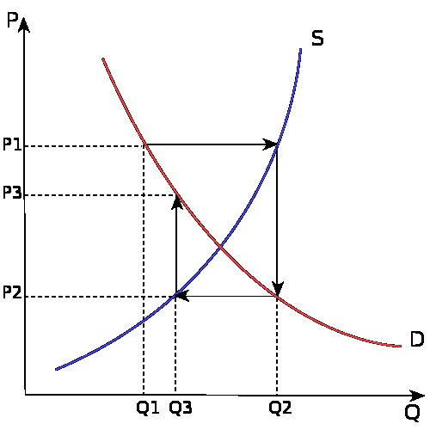

This process is illustrated by the diagrams on the right. The equilibrium price is at the intersection of the supply and demand curves. A poor harvest (i.e. fewer tomatoes) in period 1 means supply falls to Q1, so that prices rise to P1. If producers plan their period 2 production under the expectation that this high price will continue, then the period 2 supply will be higher, at Q2. Prices therefore fall to P2 when they try to sell all their output. As this process repeats itself, oscillating (variation) between periods of low supply with high prices and then high supply with low prices, the price and quantity trace out a spiral. They may spiral inwards, as in the top figure, in which case the economy converges to the equilibrium where supply and demand cross; or they may spiral outwards from equilibrium point, with the fluctuations increasing in magnitude.

In the basic model of supply and demand, the price adjusts so that the quantity supplied and the quantity demanded are equal. The precise mechanism that achieves this equilibrium is not always definite.
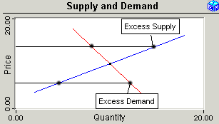

The Cobweb Model shows how achieving a supply and demand equilibrium might be so automatic if, as seems reasonable, the suppliers set the price and the consumers respond with a quantity demanded. For some slopes (elasticity) of the demand and supply curves, the equilibrium can be unstable (go far away from equilibrium). The Cobweb Model is the classic demonstration that dynamic behavior by economic agents might not touch to a stable equilibrium with supply equal to demand. This application provides two ways to graph the outcome and lets you experiment with the key parameter that determines whether the outcome is stable or not.
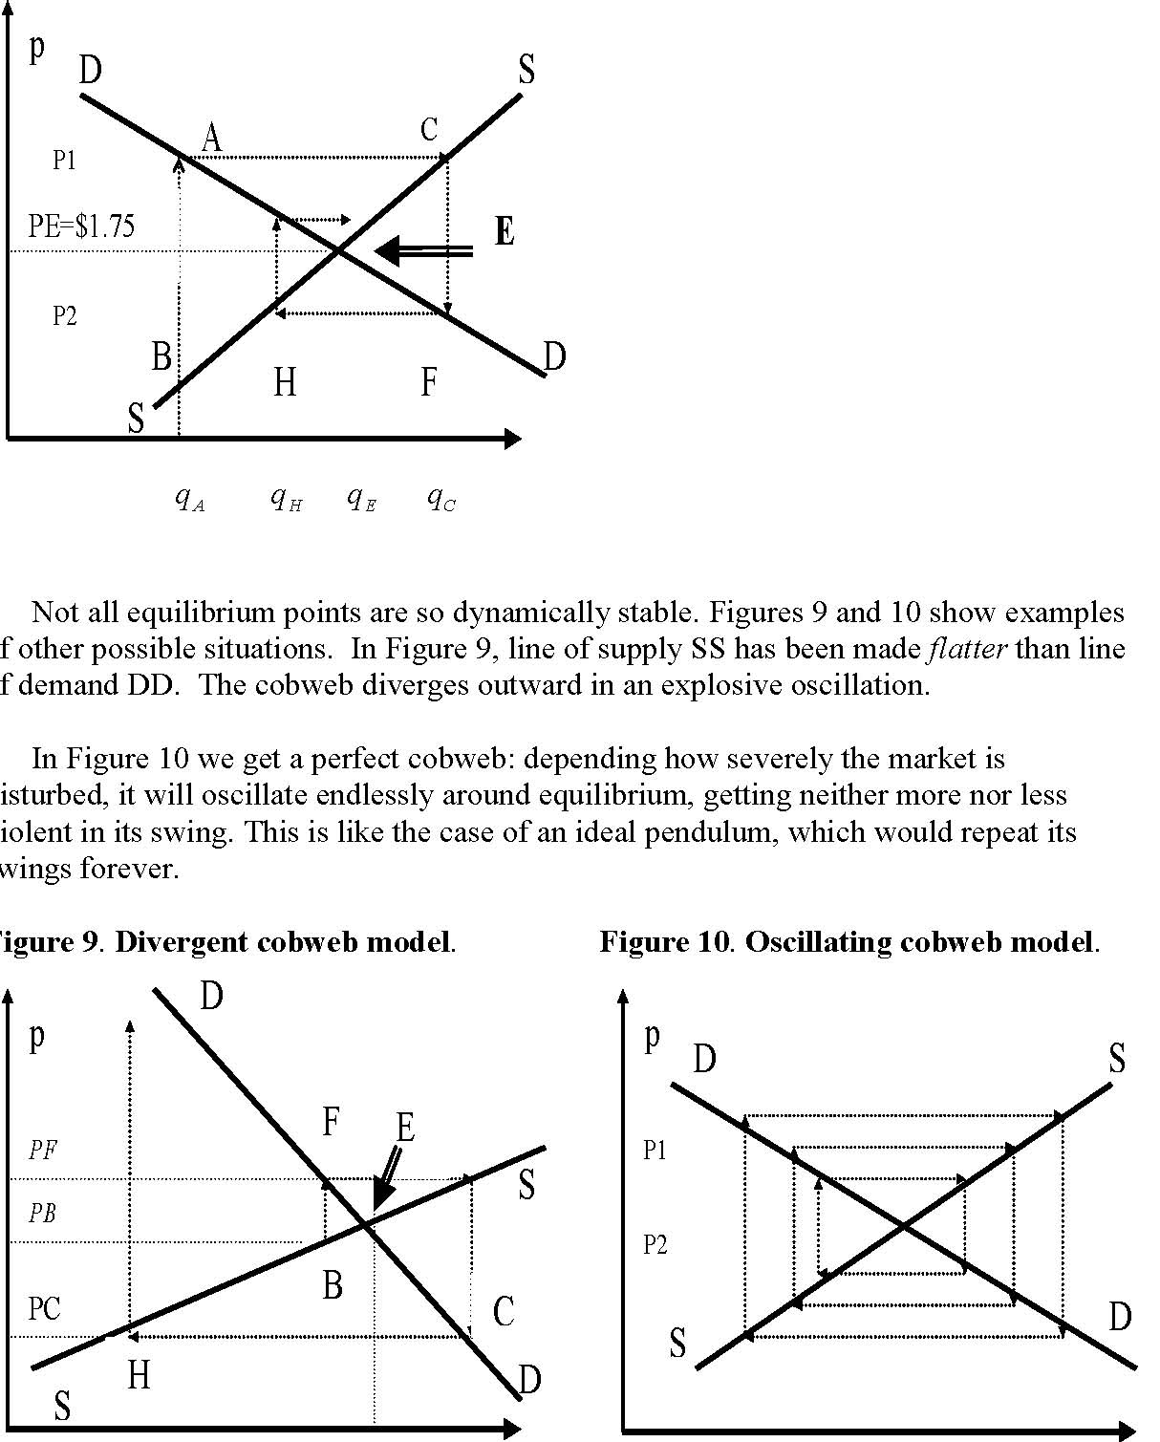
Figure 8 was drawn with the line of supply SS at E steeper (less elastic) than the line of demand DD. So, as can be seen from the diagram, the oscillations finally do dampen and die out: the cobweb winds inward to E. We are then back at equilibrium, were we can stay for a long time, until the next outside disturbance comes to set off still another dying-out oscillation.
Concept in brief by M A Jalil: (3 equilibrium cases of Cobweb model based on slopes/els)
Figure 8 - stable: When demand is flatter then point goes spirally towards equilibrium and stay at equilibrium for a long time.
Figure 9 - unstable: When supply is flatter (DD inelastic-less responded) then point goes far away from equilibrium.
Figure 10 - spiral: It is variated endlessly around the equilibrium like clock.

